# Steps to use the TwitterTool.exe

## Create your custom app on twitter

Log in to <https://apps.twitter.com/app/new>

You should have enabled the developer API access for your twitter account.

Click on Create an app. Enter desired information like

App Name: *<Test or anything>*

Application description: *<Test or anything at least 10 char long>*

Website URL: *<https://www.google.com or anything>*

Tell us how this app will be used: <*100 char long description*>

Create the App.

Now you will see following screen

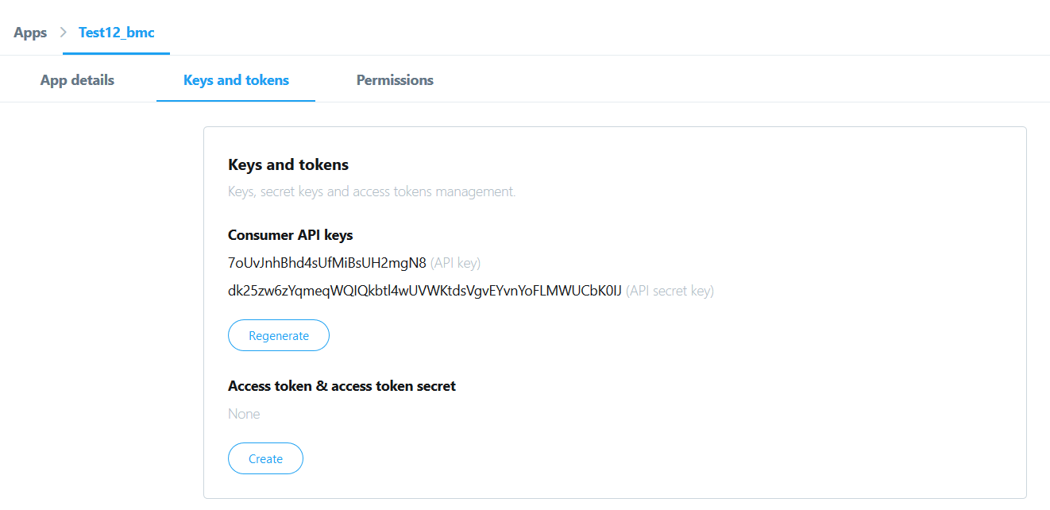

Click on **Create** for Access token & access token secret.

Now you will be having 4 things

1. Consumer/Client API Keys
2. Consumer/Client API secret keys
3. Access token
4. Access token secret

Paste these information in the attached config.py file.

Now you are ready to use the App.

## Start with TwitterTool.exe

Click on the TwitterTool.exe

A command prompt window will open, which will open the following pop up

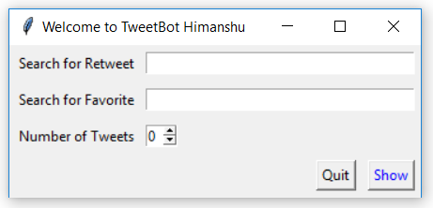

In first text box, put the string which you want to search for retweeting.

In second text box, put the string which you want to search for favouriting.

In third row, there is a number wheel. Select the number which you want to search for Retweeting and Favouriting. This will only consider those many tweets for Retweeting and Favouriting.

Like you have mentioned ***“Remedyforce”*** in first two text boxes and 5 in wheel. Then this app will search for Remedyforce keyword and take in consideration first 5 for retweeting and favouriting.

Log file will be generated every time you run the app.

**Enjoy the faster and easier RF Social tool for** 

References:

<https://developer.twitter.com/en/docs/basics/authentication/guides/securing-keys-and-tokens.html>

<https://www.slickremix.com/docs/how-to-get-api-keys-and-tokens-for-twitter/>